Empty Space between image thumbnail and “Select Media” button at hotel page when click on (+) button (done)

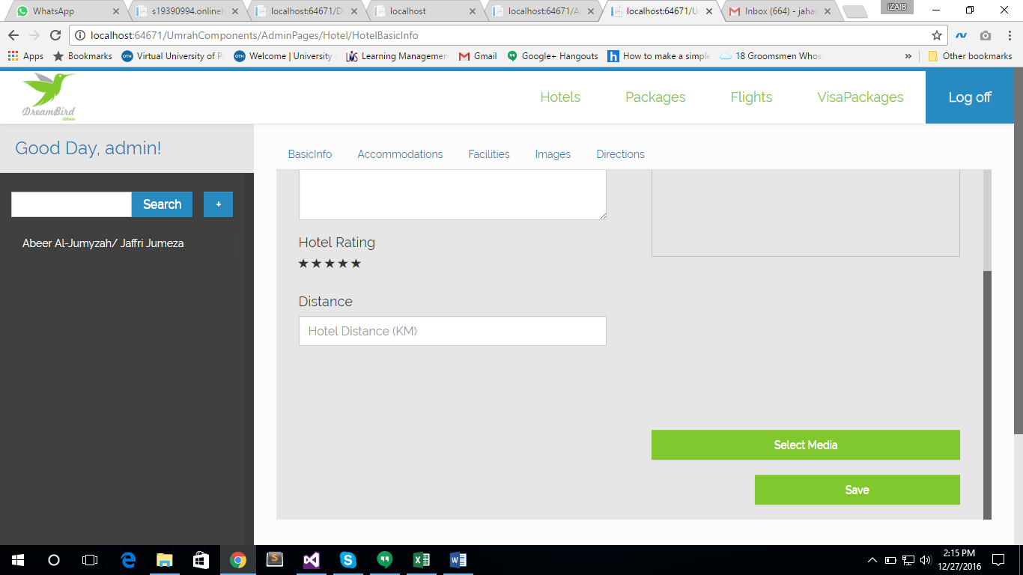

Hotel distance floating point issue, when gave distance 1.4 KM, it turned out to be the mentioned below image (done) However, when the value is added initially, this floating point number is visible, but upon saving, it vanishes.

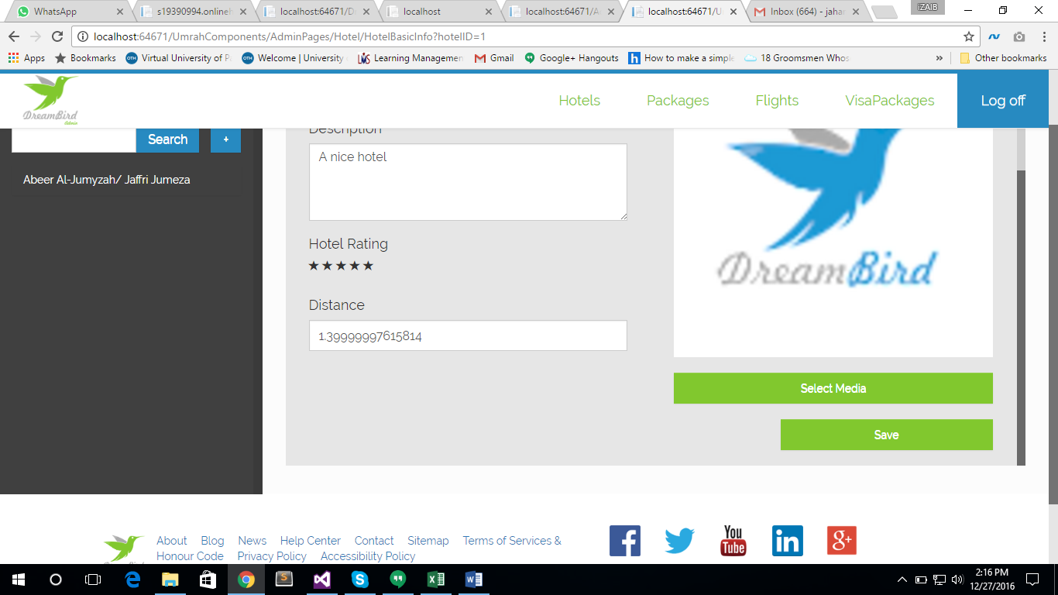

When Selected a hotel, and clicked on “Save” this exception occurred. (done)

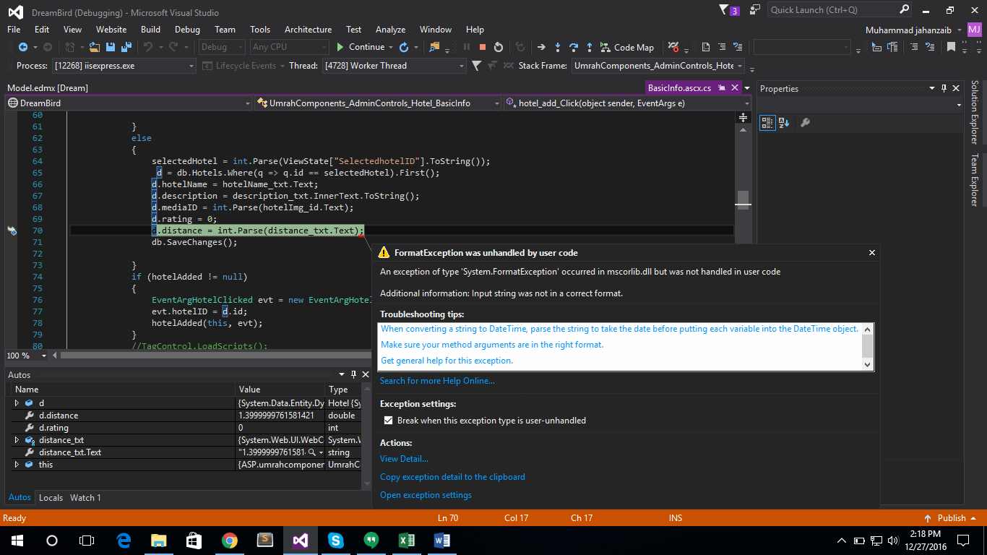

*suggestion

CssClass of textbox in accommodation page repeater may be changed to “form-control” for better visibility. See the image below (done)

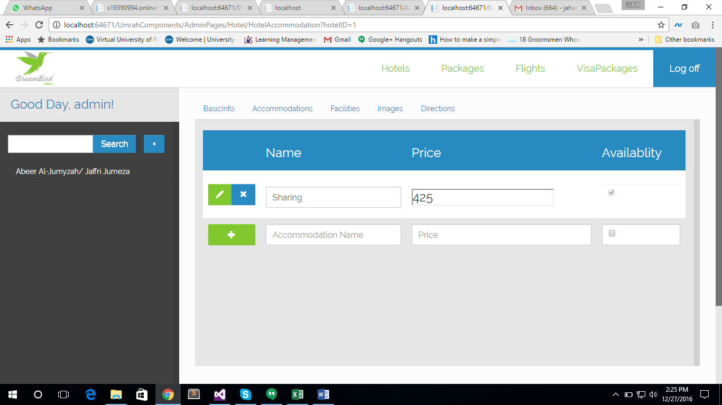

While adding second accommodation, the following error occurred. I guess, the table is not auto incremented. Same error occurred while adding first facility for second hotel. (Manually add identity in accommodation table. Or use new script for UmrahComponents)

Added Identity for this table, but when added an accommodation, the following issue occurred.

*{"Cannot insert explicit value for identity column in table 'Accommodation' when IDENTITY_INSERT is set to OFF."}*

*{"Violation of PRIMARY KEY constraint 'PK_Accommodation'. Cannot insert duplicate key in object 'dbo.Accommodation'. The duplicate key value is (0).\r\nThe statement has been terminated."}*

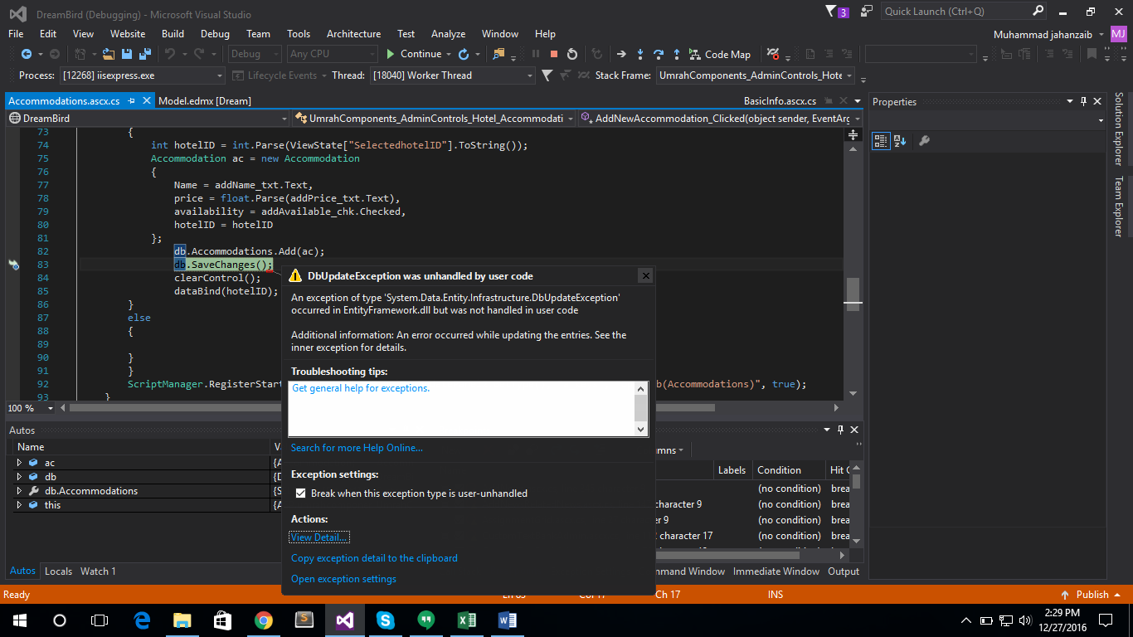

Image is not bound when clicked on edit facility button. User have to re select the image from media bank, other wise required field validator reacts. Preview image after adding facility is also squeezed. (done)

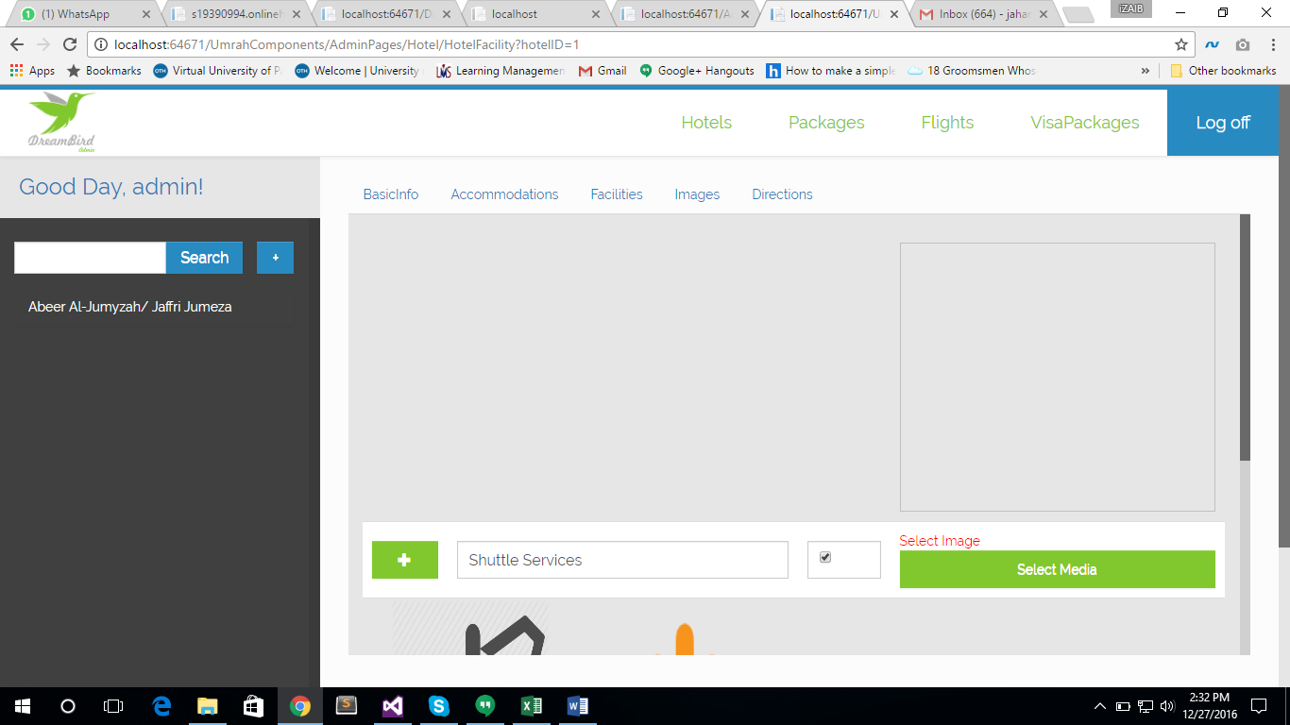

*suggestion

This flow of adding a hotel facility is confusing, it should be better, alteast the facility addition module should be in the bottom of for better understanding after adding or editing new facility.

There is a huge empty space when clicked on facility page of already added hotel. This is the image after scrolling a little bit.

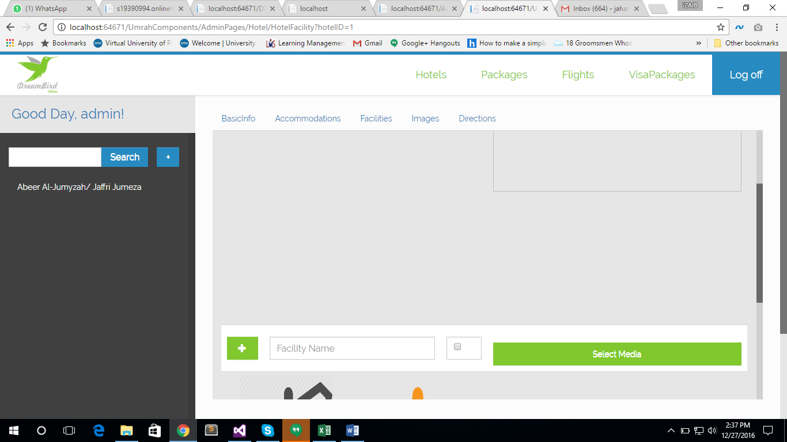

This is the image when page is opened. (done)

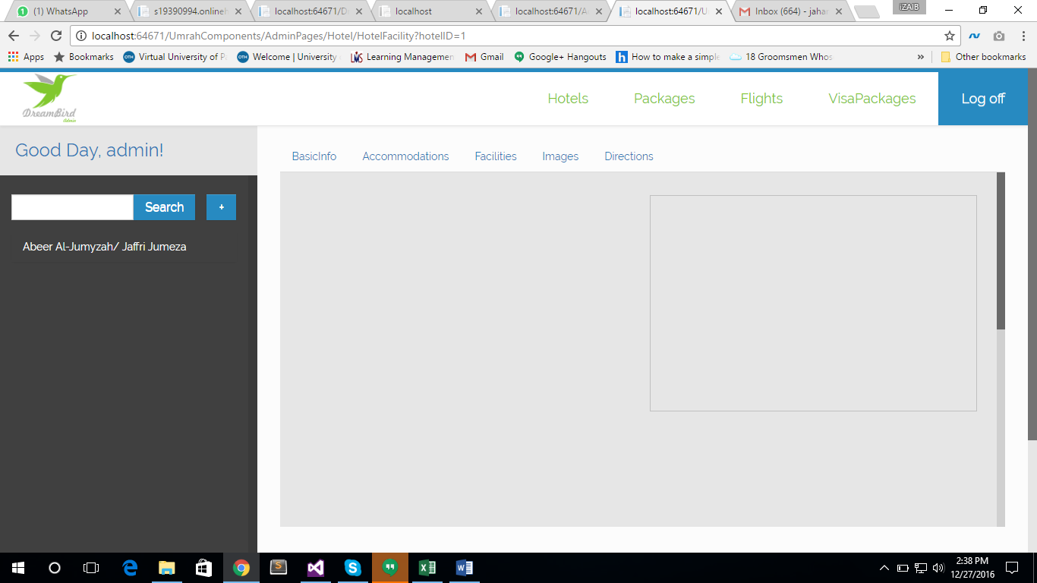

Facility with no value is saving also, at my pc, deleting the (X) button twice deletes the entry, not on the first click. Also the thumbnail image is too large and is not with actual proportions. It is suggested that 100x100 type of thumbnail may be used with actual 100x100 px dimentions.

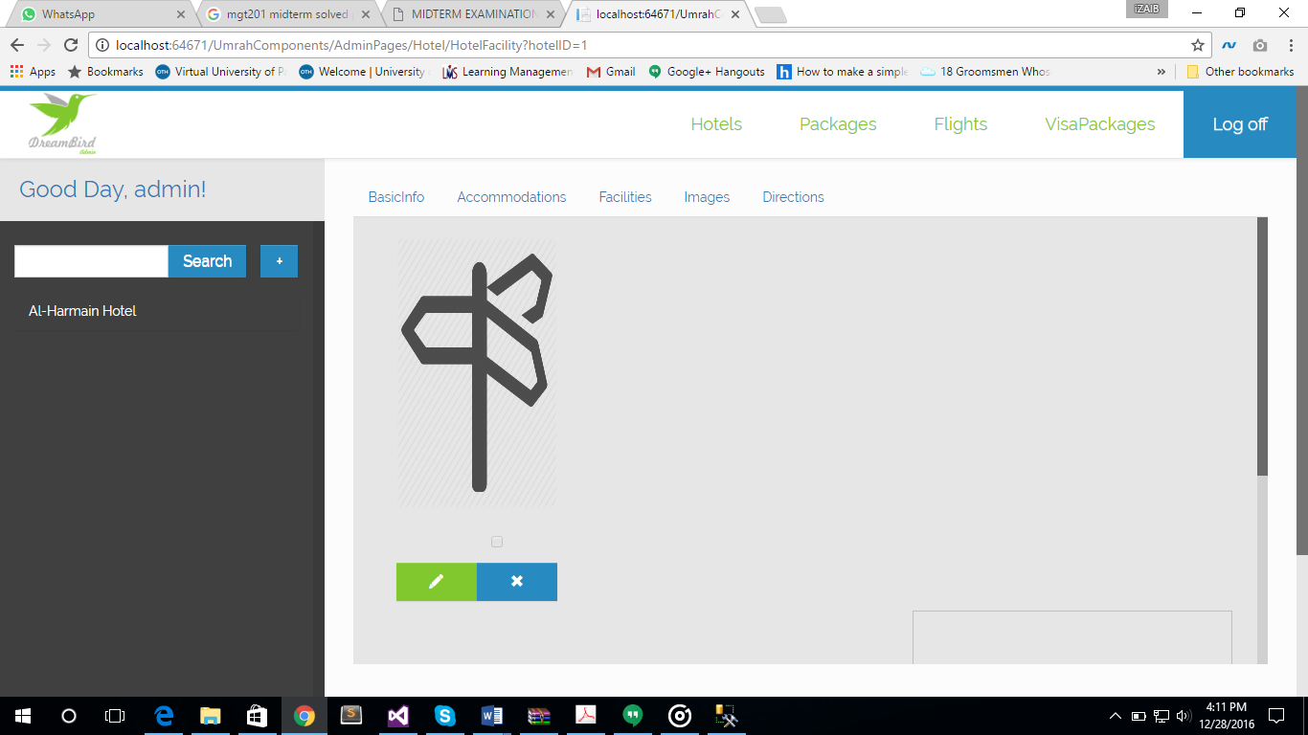

No way to remove or disable the selected images for hotels. (done)

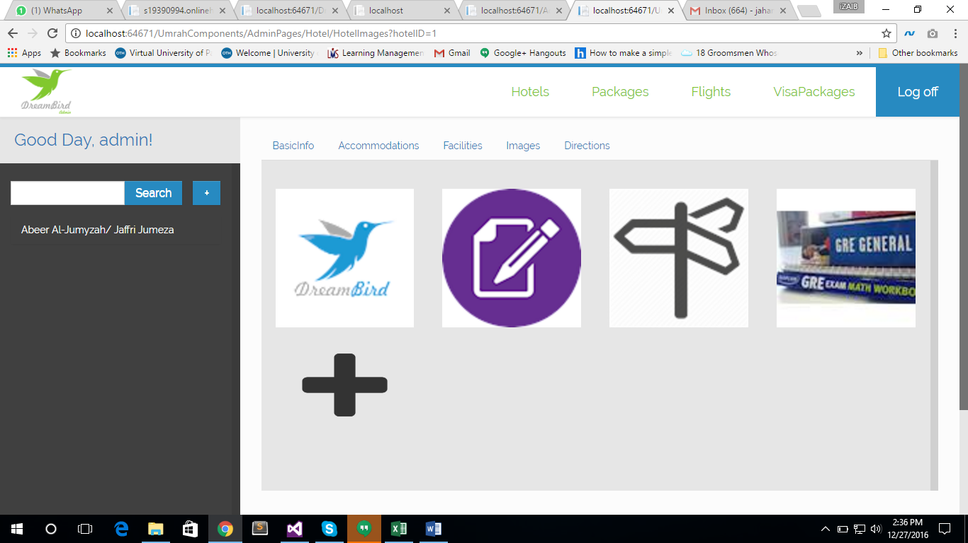

There should be “Airline Name” instead of “Flight Name” in the home page of flights as per the design. (done)

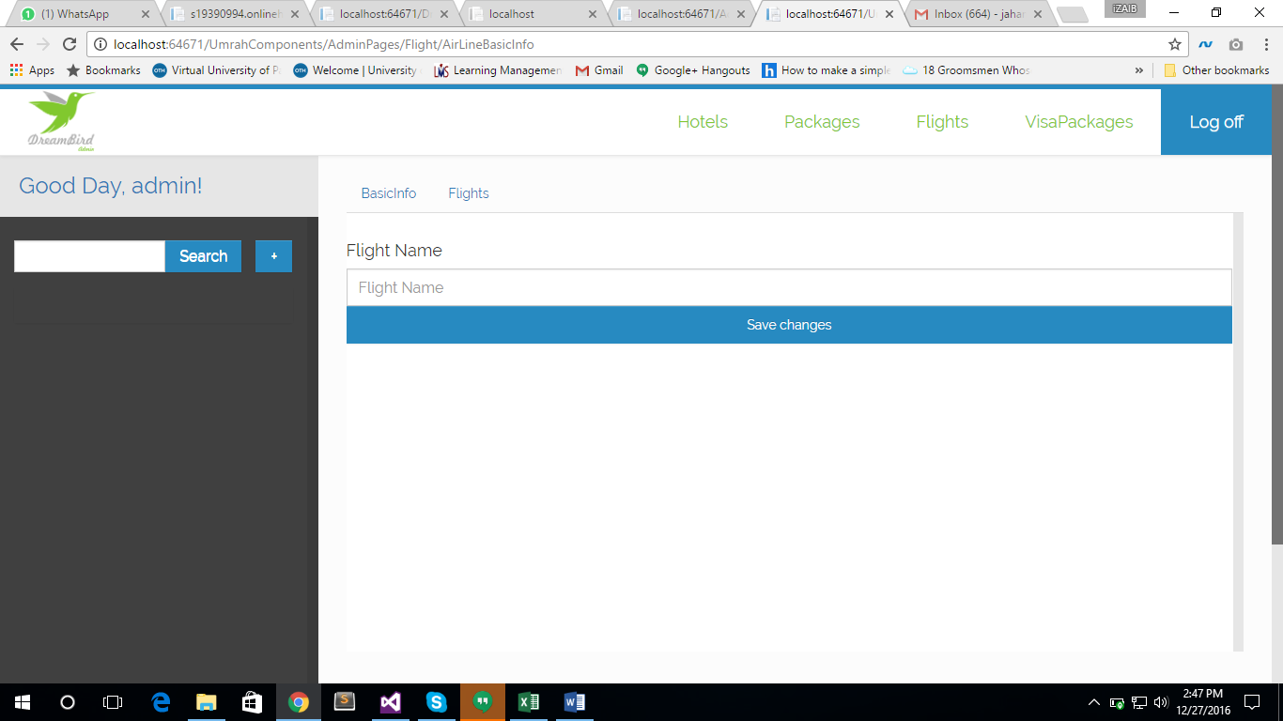

List of Flights is not refreshed when clicked on “Save Changes” (done)

No way to proceed further after addition or selection of flights from the list. (done)

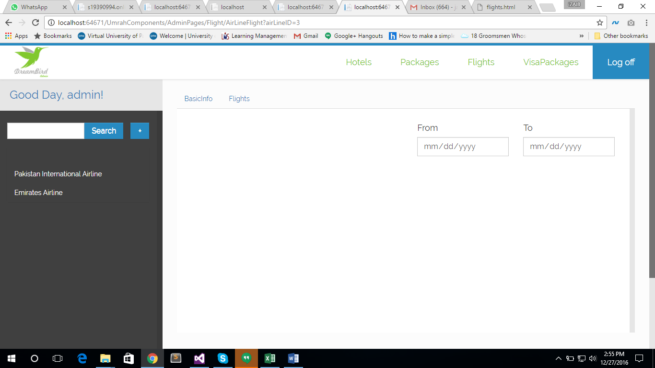

Clicking “Save Changes” on empty form of flight page is giving the following exception

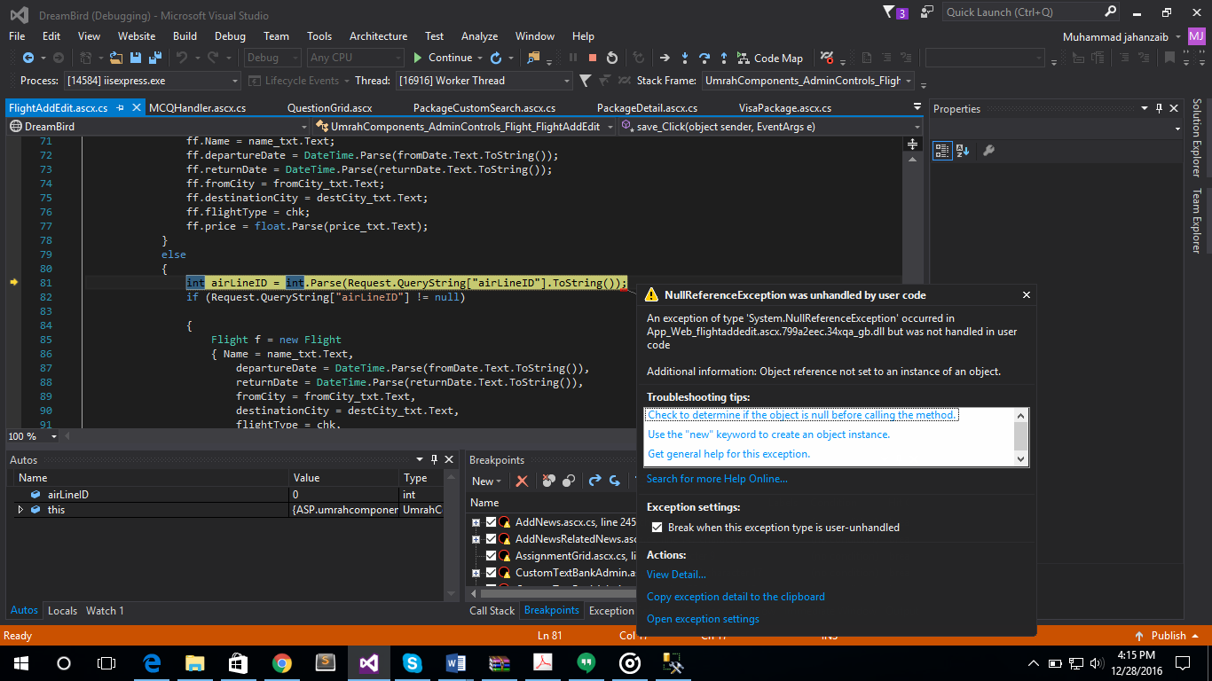

On this page, required field validator may be applied to every field.

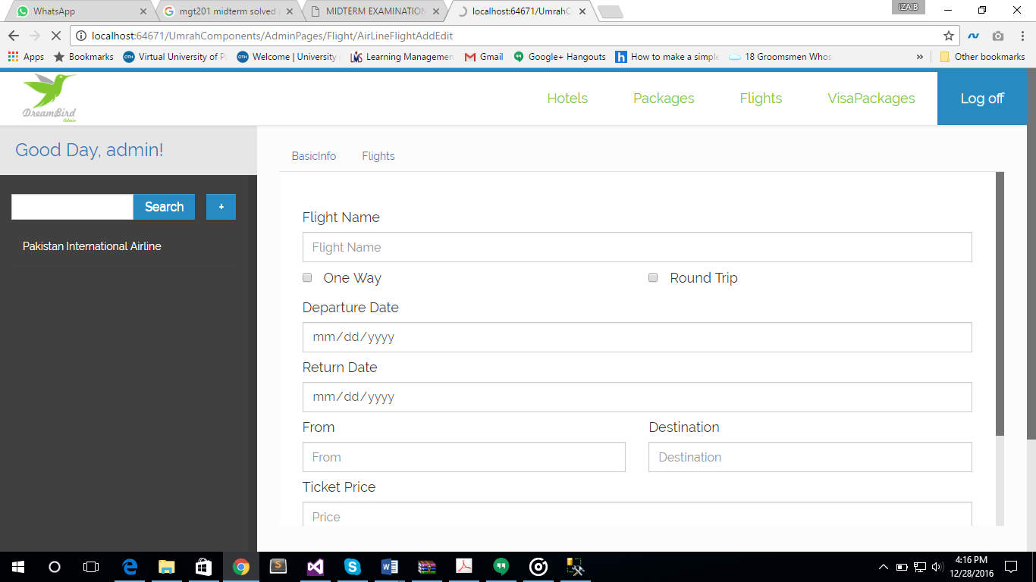

Same error occurs when vales are added and clicked on save changes. When selected an airline and clicked on “Add Flight” button from flight page, the flight id in query string is cleared as it can be seen in the above image.

Transport, Flights and Ziarat are not bind on adding package detail page. See the image below. (Manually Add data for Ziarat and Transport, Script added in “DataFile.sql”

Add Flights through Flights interface)

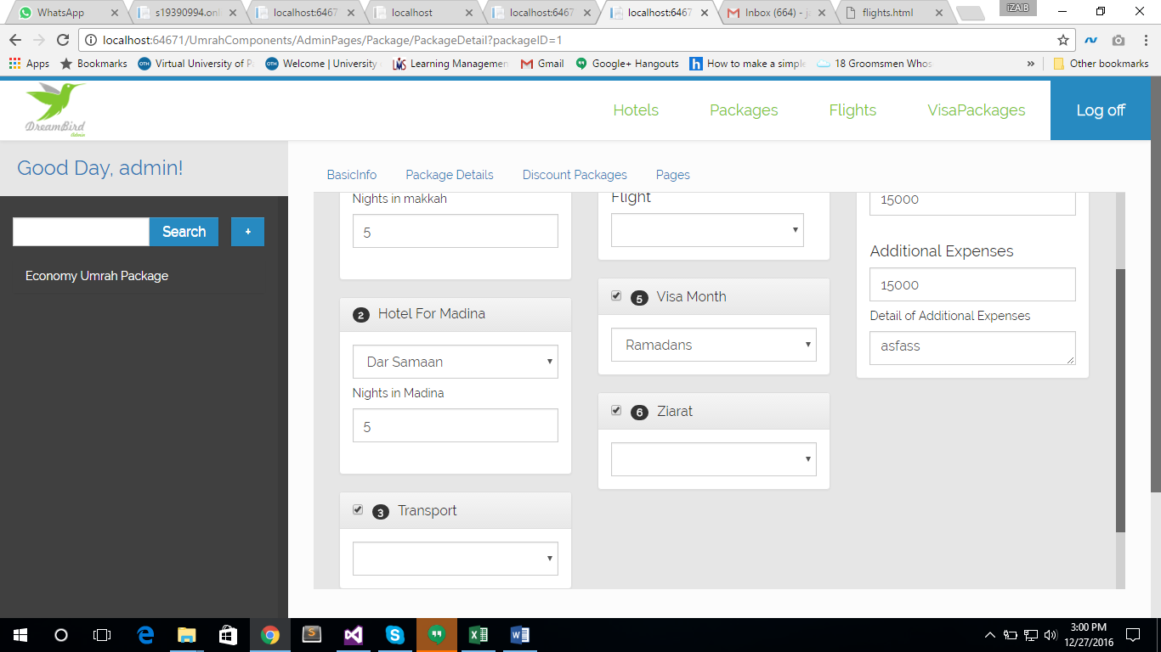

Whithout this binding, the following error occurred.

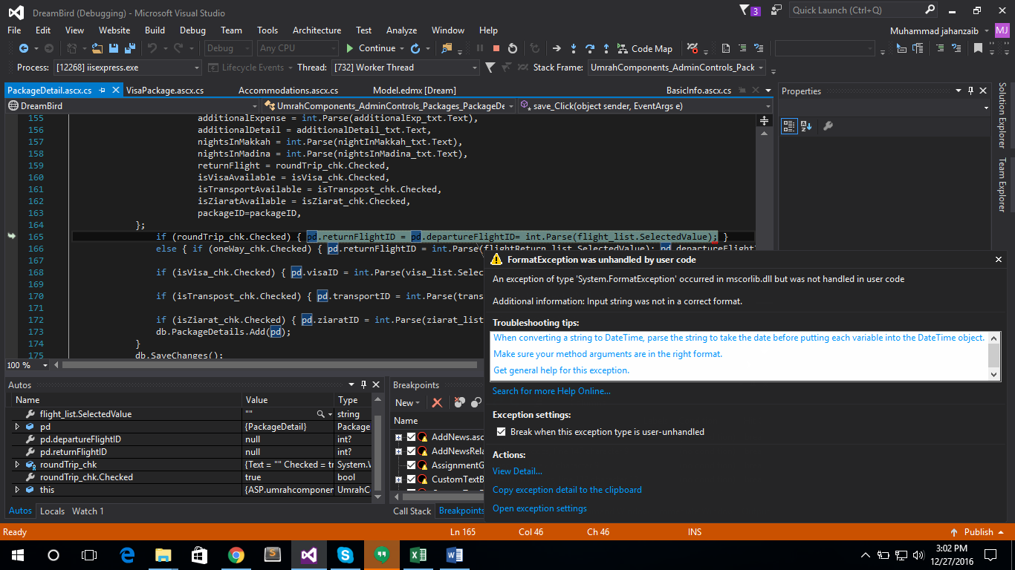

There should be restriction of alerting the user if there is no flight selected or any value that is essential for package is missing upon saving the package. Also number of nights for Makkah and madina combined may not exceed from the package duration given in the first page. As the flight interface is not working properly, I am not able to check the further flow in this page.

Discount percentage should not be above 100%, css style “form-control” may be applied to the check boxes of the grid. (done)

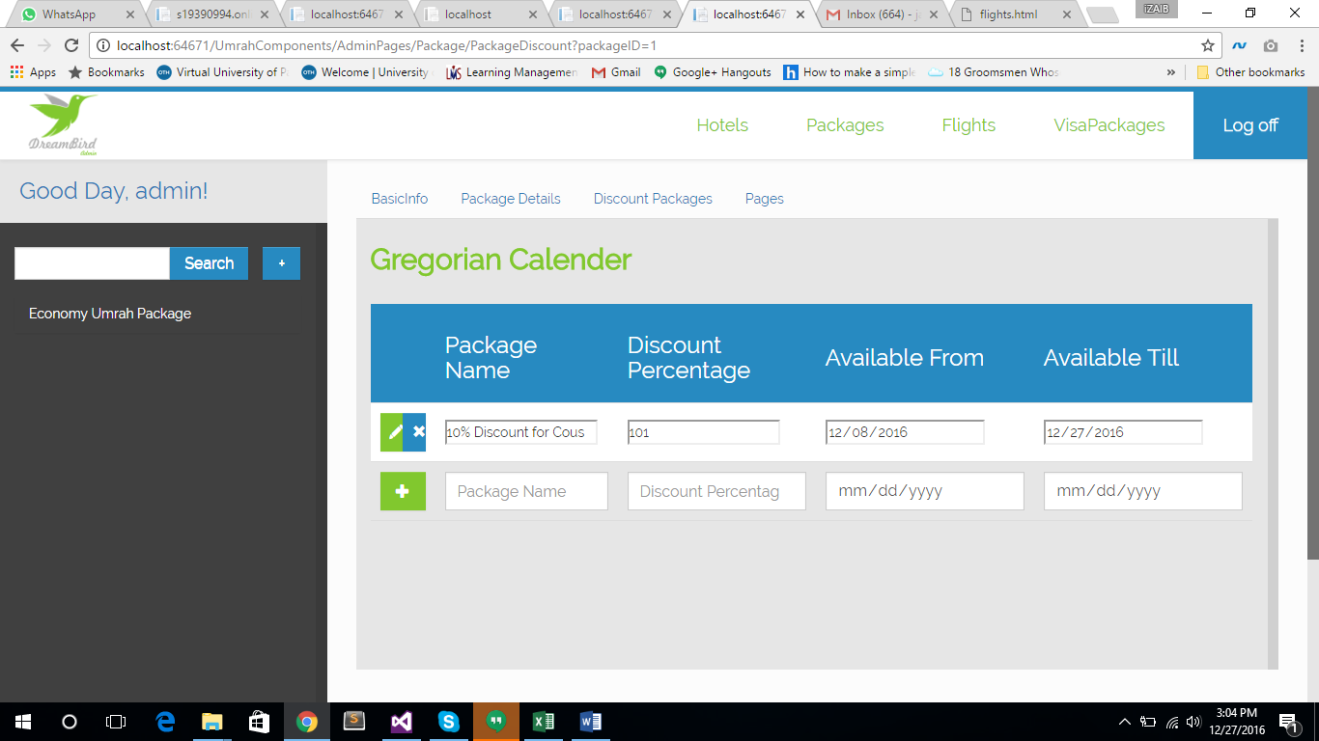

Following error occurred when clicked on the “Pages” tab (Not Requirement)

This link may be disabled.

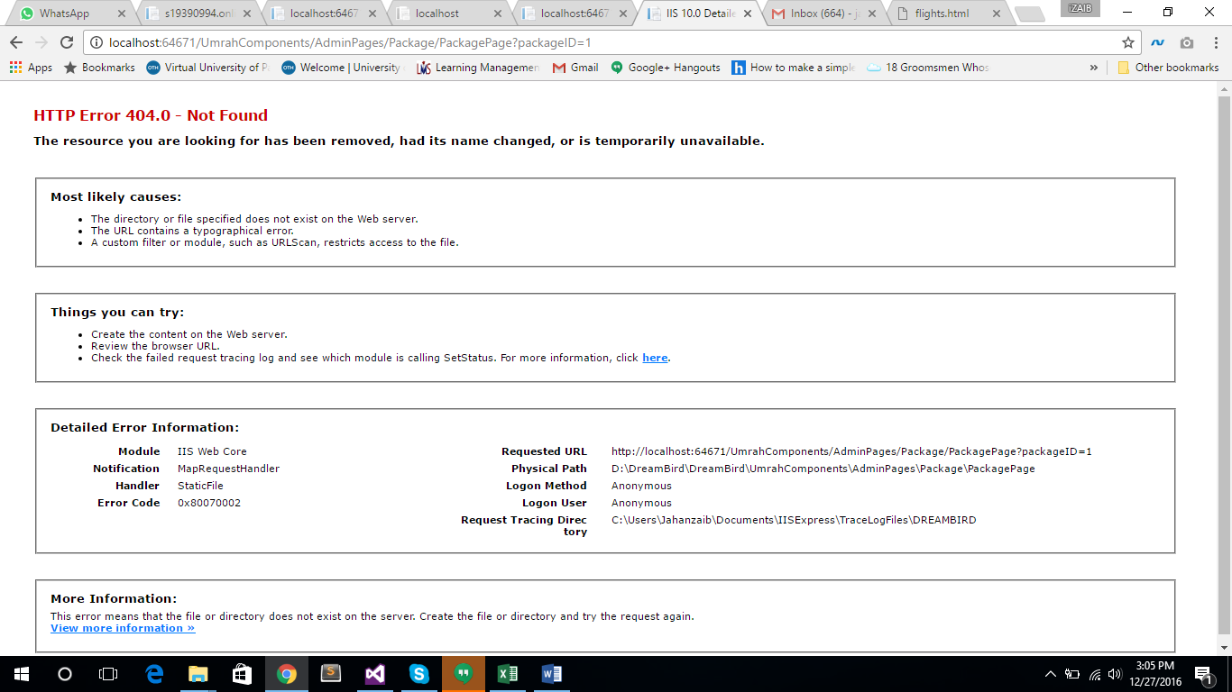

When opened the home page, following exception occurred. (done)

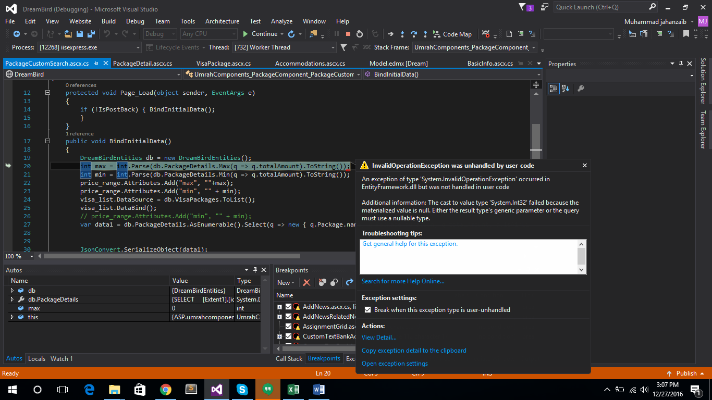

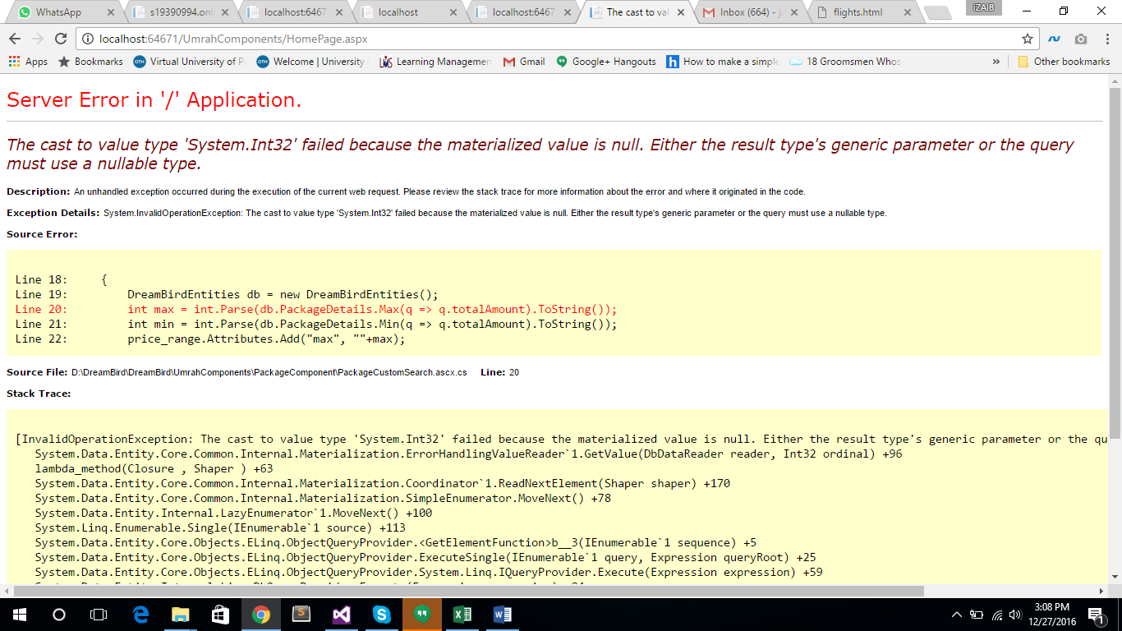

If layout / design of home page is finalized, than it is not as per the design.

In the below image, only those ratings should be bound in the dropdown list, of which the Makkah Hotels are listed. If there is no 4 star hotel for Makkah, than 4star may not appear in the dropdown list.

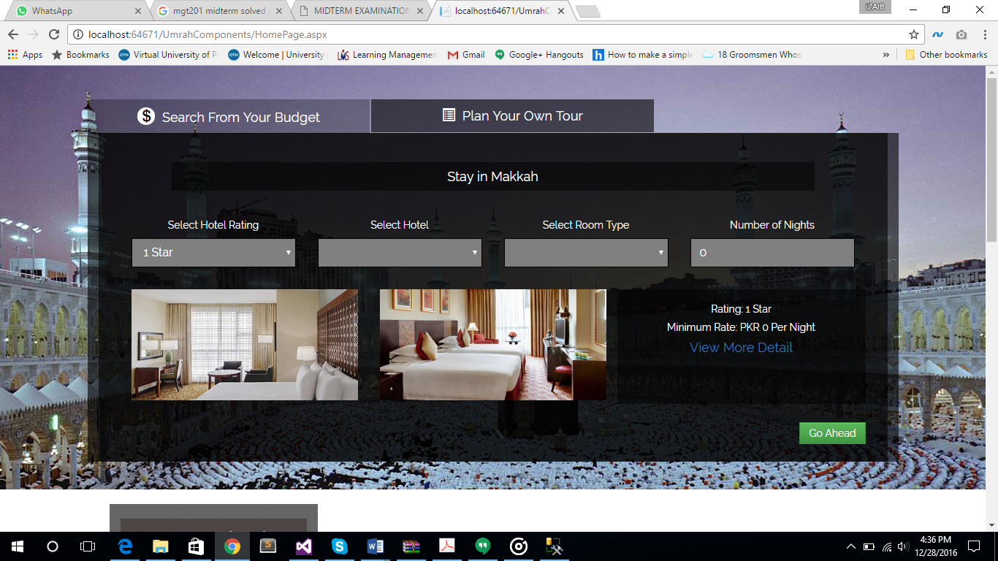Same is for hotels of Madina.

Once the flights module starts working properly, it will be tested, however if there no hotel selected, than clicking on finalize order gives the following issue.

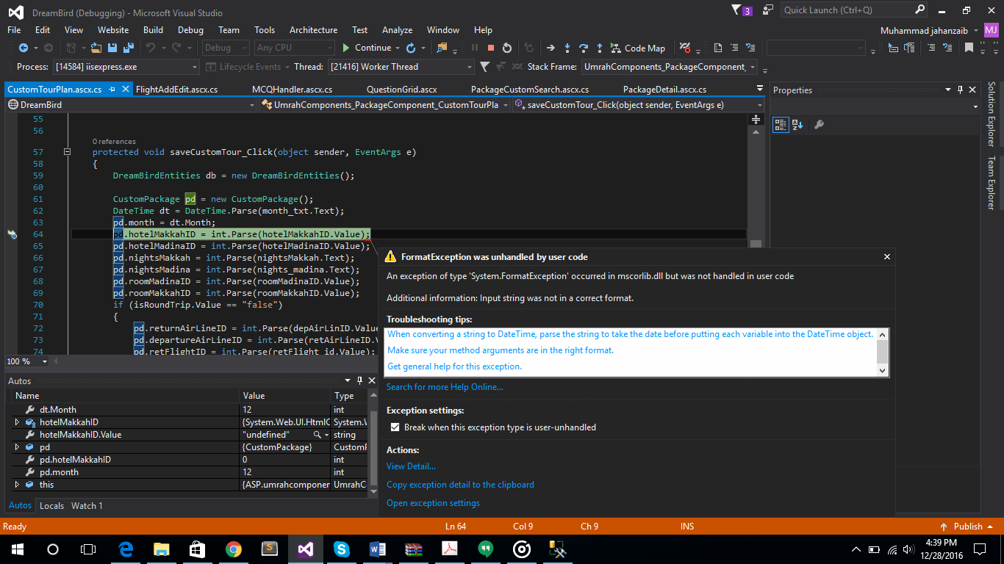

If selecting a hotels and selecting flight is mandatory, than user may be restricted to proceed further without selecting the one. If the package is such that only visiting Madina is included in the package, Not Makkah, than the error should be handled on the event of finalizing the order.